6 The Overlay and the Maze
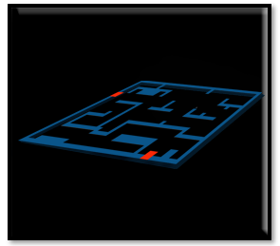

The Overlay
People who create game professionally will often use a maze overlay to be able to create their mazes for the rooms. This is a process which is used especially when a maze is extremely complicated. We will take a look at creating this overlay for our room; however, we will be keeping our own maze simple.

Create the Sprite
In the Asset Browser, you want to click on the room. So, we can see the properties for the room, on the right side of the app.

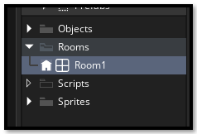

On the left-hand side, get the dimensions of your room. Your rooms dimensions need to be divisible by 32px, or 64px. Because the walls will be 32px and the hero and door will be 64px.
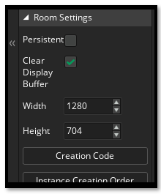
Go to Photoshop

Create your canvas at the same size as your room.
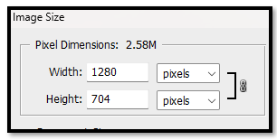
Just find a maze (online, image search) and place it on top of your new canvas that you made in Photoshop. Turn on the 32 x32 grid to place the wall map. Just remember the hero is scaled in at 64 x 64 so you path needs to be at least two grid squares in wide, in order to allow the hero to fit through the maze.
Double check your size in Photoshop for you grid size, you want it set for 32, because our wall tile pieces will look better, and fit better using this size.
Edit -Preferences- Guides, Grids & Slices…
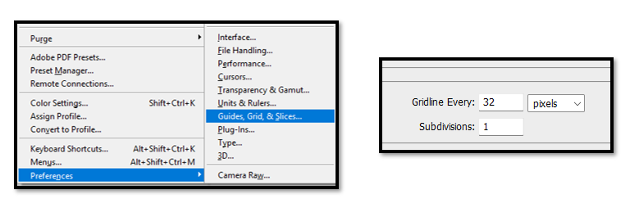
Place the maze that you brought in from the web onto your Photoshop canvas. You may have to scale it to fit the directions of the room. Fit the Maze and turn down the opacity on the maze.
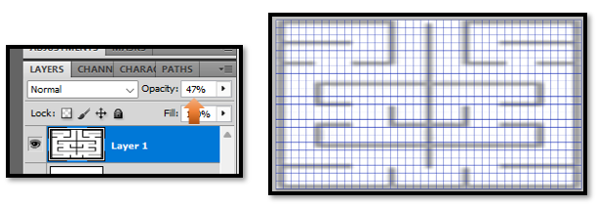

Start a new layer. Leave this new layer at full opacity.
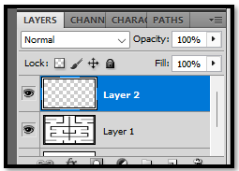
Use your marquee tool to create selections for the wall.
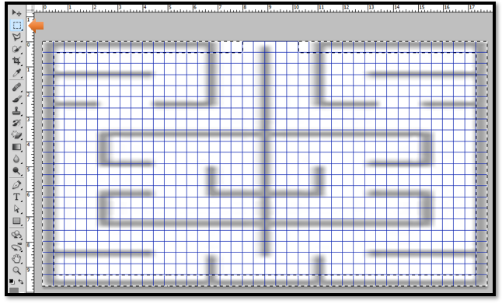
Change your top color chip to be red
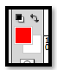
Now following (sort of) your guide start placing down a colored wall around the room. Shift – F5- Enter. This will fill your selection with the fore color of red.
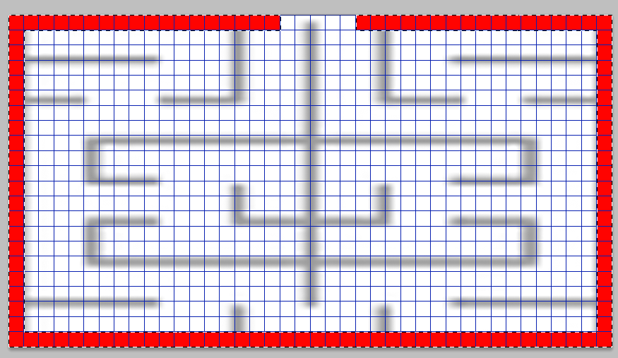

The maze being red helps it show up better on Game Makers Dark theme. You want two openings in the outer one. One is the entrance and the other is the exit. We want at least a width of 2 grid squares for the hero to be able to fit through.
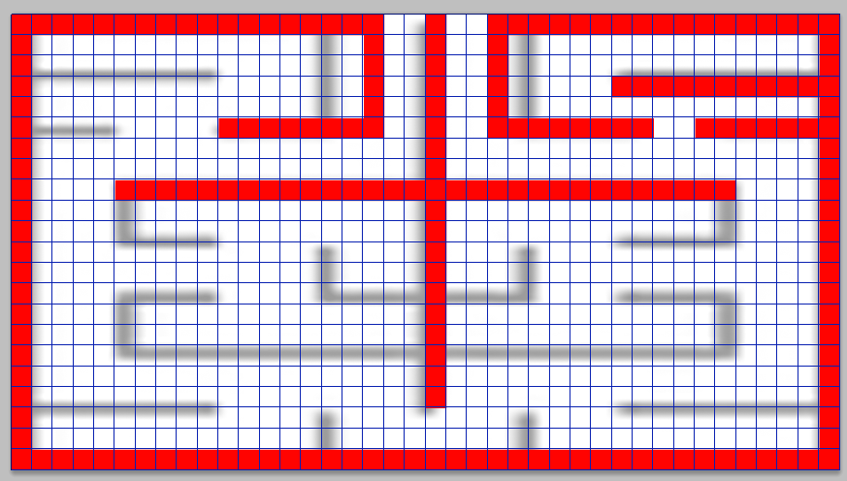

You may find your original grid that you brought in to copy might be a bit off. Just follow it as best as you can. Your final maze design should look something like the image below when keeping with the rules that we have set for creating our maze. Remember to turn off the underlying grid before you save our new grid.
